1. **Summary of data collection and the mapping process**

In our study three main indicators to explain the spatiotemporal behavior of the pandemic were selected (COVID-19 infections, COVID-19 deaths, and excess mortality), collected at NUTS3 level and analyzed accordingly. In this document we show from where data was collected, preprocessed and how it can be updated. Herein, we describe the steps to create a local comprehensive and an updated geodatabase. Overall, our data collection and mapping process follow three major phases. The first in which we collected the data (number of infection, deaths and excess mortality at the highest level possible NTS3). The second, in which we harmonized the data by date format and NUTS id, and generating several databases with different time frames ranging from daily database to monthly database. In the third phase, we generated maps, and animated maps.

**Phase I: Data collection** **(COVID-19 infections, deaths and excess mortality)**

Data was collected manually (except the Netherlands which the Ministry of Health facility provides an API to retrieve data and updated it each time we re-execute the python script) from official sources (Ministry of Health for each EU country) as highlighted in section *2. Data sources*.

For some countries such as Greece, Norway, and Luxembourg data was harvested from the official website of the World Health Organization [WHO COVID-19 Explorer (shinyapps.io)](https://worldhealthorg.shinyapps.io/covid/), because county-level data was highly populated with missing values especially for Greece.

Data was manually collected and hosted in one single folder representing the name of the selected indicator, next data was called and processed into a dataframe format using a python script:

**Make a screen shoot (code ~Poland)**

Once the dataframes were created for each country, we merged all the dataframes into one single dataframe using the *date* variable as key.

While constructing the local database, several countries such as Portugal, Greece and Italy showed NaNs cells (i.e., missing data points), the missing cells were filled by the previous values (using the same NUTS id).

The data used for this study is made publicly available and accessible from the repository: [mohamed-hachaichi/ESPON-DATA (github.com)](https://github.com/mohamed-hachaichi/ESPON-DATA) containing daily, weekly and monthly datasets, the and it is structured as follows:

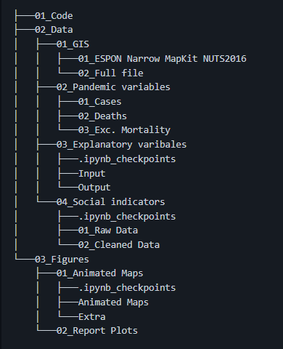

**Phase II: Data harmonization**

To harmonize the data across EU regions and timeframe, we used a python script that ensure computing the same values for each selected date format (weekly or monthly) to ensure harmony and consistence, and comparability across maps.

After, each dataset was merged with the EU-ROPA GIS layer to construct a geodatabases to be used for spatial and cartographic studies. After, the projection type of the geodatabase was converted from *WGS84* to *epsg 3035* (single CRS for all Europe) using the European Terrestrial Reference System 1989.

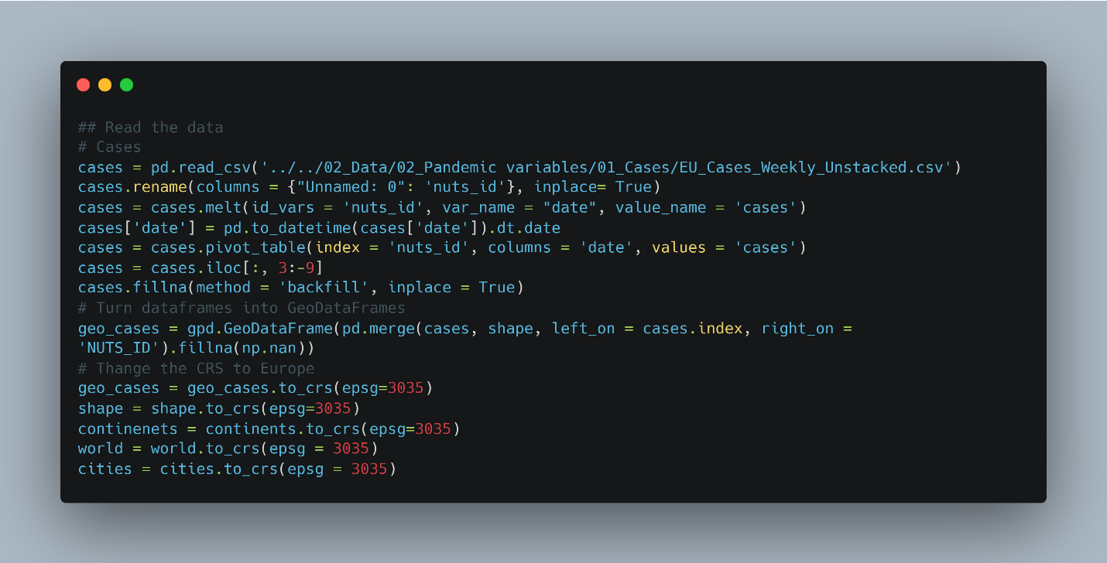

**Phase III: Data mapping**

Two types of maps were generated during this study: (1) choropleth maps to depicts the evolution of the pandemic within the spatial boundaries of each regions, and (2) an isopleth maps based on a spatial interaction model to display to reach of the pandemic regardless of the geographical boundaries of regions.

To generate choropleth animated maps we used a python automated script to generate maps including number of COVID-19 infections, COVID-19 deaths, cumulative number of COVID-19 infections, cumulative number of COVID-19 deaths. The python script uses a recursive function to merge the maps into an animated map.

The python script loops over the geodatabase and generate a map corresponding to a date (whether on a daily, weekly or a monthly basis) as follows:

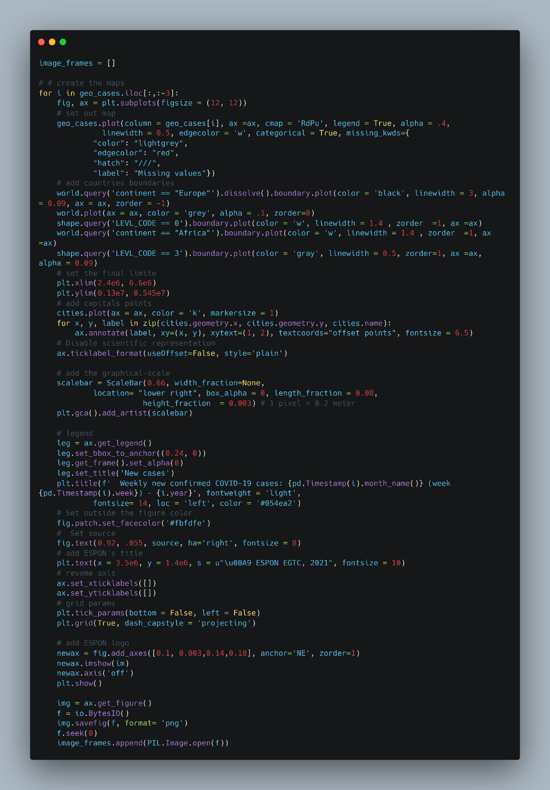

After to turn each create image with the same high resolution, we used another python script:

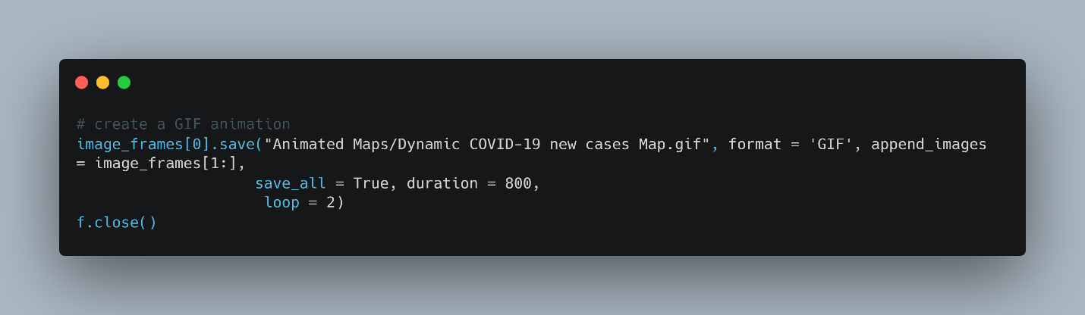

In this demo, we specified that the animated map will be displayed in a duration of 800 second (), and the animated map will loop for 2 times and then it became statistic. You can change both parameters to control the speed of the animation and how many times the animation can loop.

Map show a static example of the output:

**Put a figure here (choropleth)**

To generate isopleth animated maps we used a ArcGIS (a SIG software) to create smoothed maps. We used the Inverse Distance Weighted (IDW) interpolation method which calculates cell values by combining a set of sample points in a linearly weighted way. Inverse distance determines the weight. The interpolated surface should be that of a location-dependent variable.

manually a total of 97 maps for each indicators were generated as shown here:

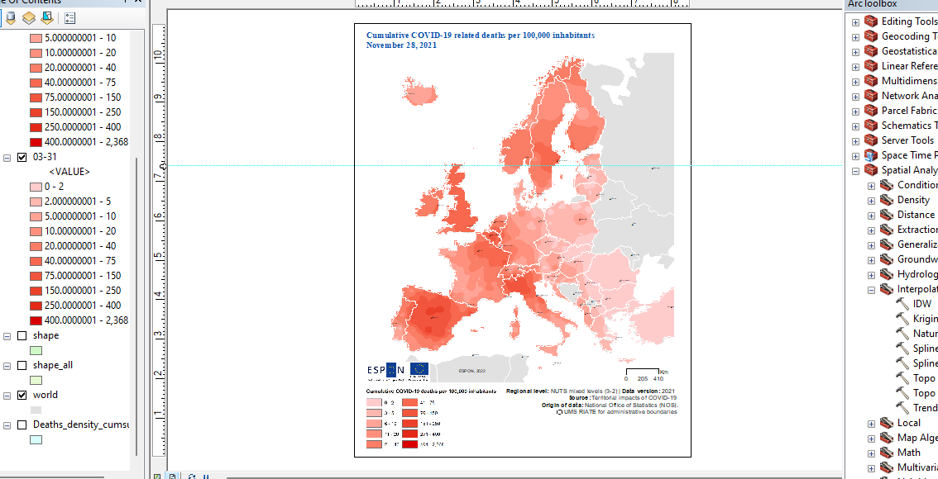

After generating all the maps (corresponding to all the weekly dates), were placed in a specific folder



A random sample of this process is

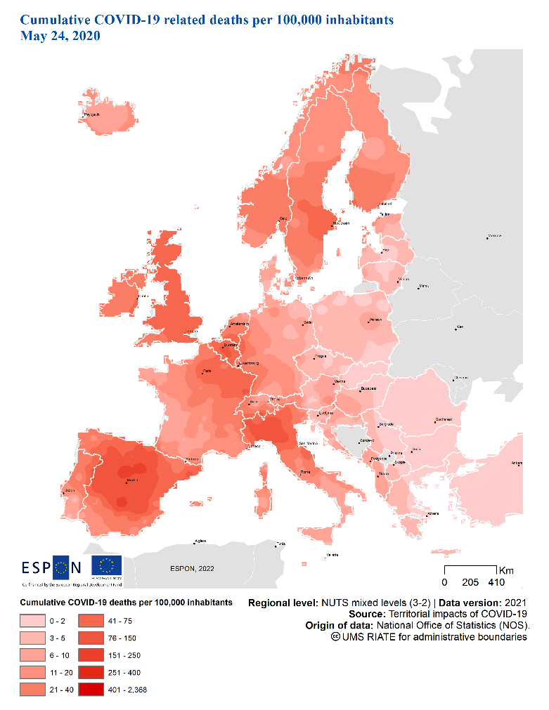

Once we create and gathered all the map (starting from January 16, 2020 to November 28, 2021), we written a python script to create an animate map. The raison we chosen to create a tiny software to read and gather maps was because the other existing software reduce the quality of animated maps.

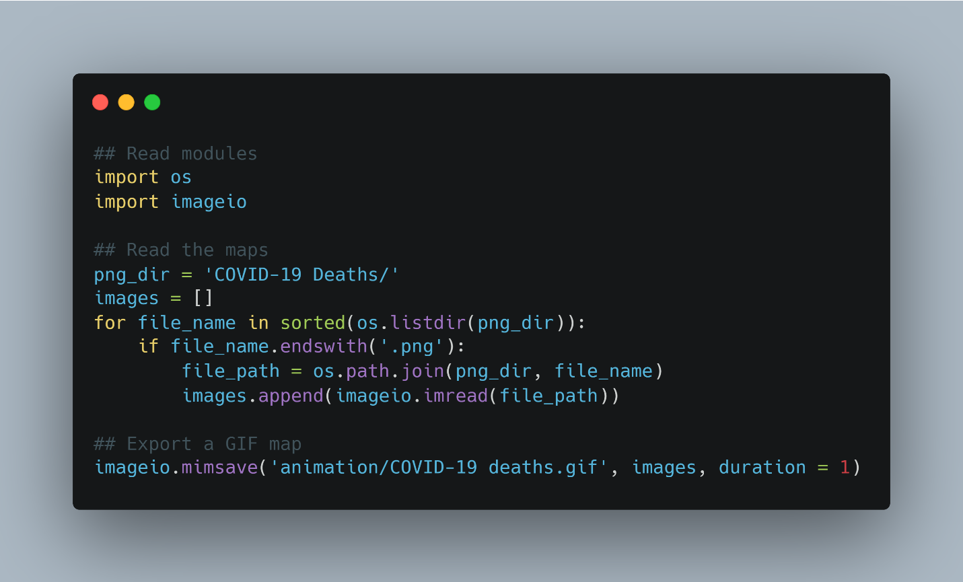

1. **Source of data**

* BE

<https://epistat.wiv-isp.be/covid/>

* DE

<https://npgeo-corona-npgeo-de.hub.arcgis.com/datasets/dd4580c810204019a7b8eb3e0b329dd6_0/data><https://npgeo-corona-npgeo-de.hub.arcgis.com/datasets/917fc37a709542548cc3be077a786c17_0><https://www.rki.de/DE/Content/InfAZ/N/Neuartiges_Coronavirus/Fallzahlen.html>

* DK

<https://www.ssi.dk/sygdomme-beredskab-og-forskning/sygdomsovervaagning/c/covid19-overvaagning><https://www.sst.dk/da/corona/tal-og-overvaagning>

* ES

<https://www.mscbs.gob.es/profesionales/saludPublica/ccayes/alertasActual/nCov-China/documentos/Actualizacion_36_COVID-19.pdf>

* FR

<https://www.data.gouv.fr/fr/datasets/donnees-hospitalieres-relatives-a-lepidemie-de-covid-19/>

* IT

<https://statistichecoronavirus.it/crea-dashboard/>

<http://www.salute.gov.it/portale/nuovocoronavirus/dettaglioContenutiNuovoCoronavirus.jsp?lingua=english&id=5367&area=nuovoCoronavirus&menu=vuoto>

* NL

[https://www.rivm.nl/coronavirus-covid-19/actueel/wekelijkse-update-epidemiologische-situatie-covid-19-innederland](https://www.rivm.nl/coronavirus-covid-19/actueel/wekelijkse-update-epidemiologische-situatie-covid-19-in-nederland)

<https://www.arcgis.com/apps/opsdashboard/index.html#/cfc2084c995c40e7ae72254029bf6251>

* PT

<https://covid19.min-saude.pt/ponto-de-situacao-atual-em-portugal/><https://github.com/dssg-pt/covid19pt-data>

* CH

<https://github.com/openZH/covid_19>

[/https://www.bag.admin.ch/bag/en/home/krankheiten/ausbrueche-epidemien-pandemien/aktuelleausbrueche-epidemien/novel-cov/situation-schweiz-und-international.html](https://www.bag.admin.ch/bag/en/home/krankheiten/ausbrueche-epidemien-pandemien/aktuelle-ausbrueche-epidemien/novel-cov/situation-schweiz-und-international.html)

* CZ

<https://covid19.who.int/>

<https://onemocneni-aktualne.mzcr.cz/api/v2/covid-19>

* HR

<https://www.koronavirus.hr/podaci/otvoreni-strojno-citljivi-podaci/526> <https://www.koronavirus.hr/latest-news/covid-19-weekly-report-august-31st/786>

* AT

Data collected with a need for authorization (have to wait one month between the request and the obtention of the excel file): contact:

Dr. Michael Hummer michael.hummer@goeg.at

Gesundheit Österreich GmbH

Stubenring 6

1010 Wien

T: +43 1 515 61-138

M: +43 676 84 81 91 610 [https://www.sozialministerium.at/Informationen-zum-Coronavirus/Neuartiges-Coronavirus-(2019nCov).html](https://www.sozialministerium.at/Informationen-zum-Coronavirus/Neuartiges-Coronavirus-(2019-nCov).html)

<https://experience.arcgis.com/experience/fb603473e1f74f0bbae48155ff238565/page/page_2/>

* HU

<https://covid19.who.int/>

* PL

ESPON contact Poland: Katarzyna.Powierza@mfipr.gov.pl

<https://www.gov.pl/web/koronawirus/wykaz-zarazen-koronawirusem-sars-cov-2><https://www.arcgis.com/apps/opsdashboard/index.html#/deaceebc69a3412c8b7699e3e025e213><http://www.informacjakryzysowa.pl/en/aktualnosci/covid-19-na-mapach-polska>

* SK

<https://korona.gov.sk/koronavirus-na-slovensku-v-cislach/>

<https://korona.gov.sk/en/coronavirus-covid-19-in-the-slovak-republic-in-numbers/>

## • SI

<https://covid-19.sledilnik.org/sl/stats> <https://www.nijz.si/en>

* CY

<https://covid19.who.int/><https://covid19.ucy.ac.cy/>

* EL/GR

<https://covid19.who.int/>

<https://covid19.gov.gr/covid19-live-analytics/>

* LT

<http://atviriduomenys.nvsc.lt/> [https://covid19.who.int](https://covid19.who.int/)

* LU

<https://covid19.who.int/>

<https://data.public.lu/en/datasets/donnees-covid19/>

* MT

<https://covid19.who.int/>

* RO

<https://coronavirus-esriro.hub.arcgis.com/>

<https://esriro.maps.arcgis.com/apps/opsdashboard/index.html#/ec6ee9017ee549e992e96f1b8bd7d080>

* EE

<https://covid19.who.int/EE>

* FI

<https://covid19.who.int/FI>

* IE

<https://covid19.who.int/LV>

<https://covid19ireland-geohive.hub.arcgis.com/datasets/c8208a0a8ff04a45b2922ae69e9b2206_0>

* SE

<https://www.folkhalsomyndigheten.se/>

<https://ago-item-storage.s3.us-east-1.amazonaws.com/>

* LI

<https://covid19.who.int/>

<https://github.com/openZH/covid_19/tree/master/fallzahlen_kanton_total_csv>

* NO

<https://covid19.who.int/>

* UK

<https://www.gov.uk/government/news/weekly-covid-19-surveillance-report-published><https://coronavirus.data.gov.uk/details/deaths>